**Topic:** Introducion/ Ancient Arithmetic

**Notes on Topic:** With the invention of agriculture 15,000-10,000 BC, humans had to address the issue of multiplicity and space.

Multiplicity comes into play when people are counting sheep or distributing crops.

These notions would be refined by scholars and later turned into the ideas of arithmetic and algebra.

The spatial relationship of farming, the area of the fields and pastures would continue on to become what we know as geometry.

Algebra and geometry would have naturally coexisted in primitive form.

Clear signs of math development in ancient egypt, used for agriculture, facilitate trade, etc.

Archaeological records show by 2000BC egyptians had a primitive numerical system as well as some geometric ideas about triangles and pyramids

For example: they had a clever way of constructing a right angle, by tying twelve equally long segments of rope together and creating a loop by extending five segments from point C to B, and then pulling the rope taught at some point A, they had formed a right triangle, we know now that this is the classic 3,4,5 right triangle. For them, they knew that a triangle with side lengths 3,4,5 must have a right angle, (hence the converse of pythagorean theorem) showing an early introduction to one of the most important theorems we will be covering.

Another example of egyptian mathematics: finding the volume of a truncated square pyramid- the frustum of a pyramid in today’s language. Appearing in the “Moscow Papyrus” from 1850BC **insert excerpt here about truncated pyramid** include modern formula

This excerpt lacks the ability to generalize the algorithm for different sized frusta. Most frustrating, there is no explanation why the egyptians way found the correct answer, since “You will find it right” sufficed as proof enough.

Historians have noted that a dogmatic approach was used in keeping the authoritarian society of Egypt. “Unquestioned obedience to their rulers”

The Babylonians were also advanced in this era, and more sophisticated with their mathematics, using algebraic characters on clay tablets called Plimpton 322 between 1900-1600BC.

The Babylonians also recognized the use of the pythagorean (for lack of a better phrase) triangles, and even acknowledged the 5-12-13 and 65-72-97 cases.

Babylonians, interestingly enough, chose a base 60 number system, which is still seen in our time measurements and angles

Babylonians still avoided answering the question “Why?” and focused on the “how” as the ancient egyptians had.

Turn to the first millennium BC, the the Aegean coasts of Asia Minor and Greece. These civilizations would make advancements, discoveries and achievements that forever influenced the western culture.

Greeks were involved with a strong engagement in commerce, within their own lands and across the mediterranean, the greeks rapidly developed into a sophisticated, mobile, prosperous, adventurous people.

The greeks were known to be more independent in thought and action than the western world had ever seen.

They became a strong people, not likely to submit to authority, free to debate and analyze anything they had been told, there was no unquestioning obedience.

By 400BC this civilization had spawned some of the greatest names in history, the poet Homer, the historians Herodotus and Thucydides, the dramatists Aeschylus, Sophocles, Euripides, and the philosopher Socrates.

The Greeks, profoundly successful, and not always correct, knew that their way of thinking was what would lead the world into an “undreamed-of future”, in history, this special moment is referred to as the “awakening” … from what I am unsure...

**In Class Activity:** Discuss truncated pyramid,

Actual formula: V= $\frac{1}{3}$ h ($a^{2}+ab+b^{2})$, where h is the height, a is the length of the side of the top square, and b is the length of the side of the bottom square

Ancient solution:

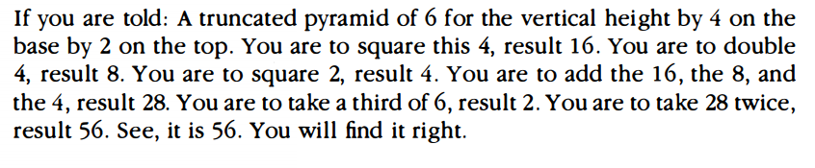

**Additional Suggested Reading**: N/A

**Assignment:** Homework 1, problem 1